Centre of Data for Public Good · Confidential
Indian Institute of Science, Bengaluru

Concept Note
Health Data Exchange (HDX)
India's Federated, Multimodal Data and Services Infrastructure for Health Research

01 OVERVIEW 1
02 THE HDX PLATFORM ARCHITECTURE 3
Overview 3
The Data Marketplace 4
The Service Marketplace 7
Federated Query Aggregation as a service 7
Federated Learning and DEPA 8
The Data provider Tooling Ecosystem 8
Field / Source Data collection utilities 8
Agentic Data Conversion and Transformation Utilities 9
Anonymisation and De-identification Utilities 9
03 Use cases enabled by the HDX 10
1. Trusted Research Environments (TREs) 10
2. Research Competitions and Hackathons 10
3. Data Collaboratives and Federated Registries 10
4. Knowledge Graphs and Data Commons 11
5. Benchmarking and Evaluation Ecosystems 11
6. Foundation Model Development and Large-Scale AI Training 11
04 WHY EXISTING FRAMEWORKS ARE INSUFFICIENT 11

June 2026 · Confidential

01 OVERVIEW

This Architecture Document translates the vision set out in the Health Data Exchange (HDX) Concept Note into a concrete technical design. Where the concept note establishes why India needs a federated, multimodal data and services infrastructure for health research — and what such a platform must accomplish across clinical evidence, genomics, and hospital engagement — this document specifies how the HDX is built.
It describes the platform as a national middleware layer founded on an open, standards-compliant data exchange protocol, under which data and services are published, discovered, and consumed through standardised, API-first interfaces without data ever leaving the fiduciary control of its originating institution.
For each track, the platform adheres to the globally accepted common data model appropriate to that vertical — ensuring that clinical, genomic, and imaging data are each represented in the internationally recognised schema for their respective domain, so that data harmonised once at source is interoperable everywhere on the network.
The HDX makes four contributions that, in combination, distinguish it from existing health data platforms:
- A federated data and service marketplace. At its core the HDX brings forward a two-sided exchange ecosystem: a data marketplace, through which institutions publish, discover, and provision datasets while retaining fiduciary control of their assets, and a parallel service plane, through which compute providers, AI-pipeline operators, and MLOps platforms register their capabilities alongside those datasets. Both are governed by the same open, participatory protocol, so that data and the means to compute on it are discoverable and consumable through one coherent, auditable set of pathways.
- Standards-compliant and machine-interpretable by construction. The platform adopts the relevant exchange standard wherever one applies — FHIR, OMOP, DICOM, GA4GH, DCAT — and integrates diverse protocols and open-source tools beneath a single architecture rather than reinventing them, extended where domains lack a minimum specification by the mCxDE profiles. Because metadata is modelled on RDF-based standards, datasets are not merely standardised but machine-interpretable: federated, cross-contributor querying and agentic workflows can discover, access, and reason over data without manual negotiation at each step.
- Privacy-preserving computation, enabled by the service plane. Confidential computation is a first-class capability of that same plane rather than something each institution must build. Through services backed by Trusted Execution Environments and secure enclaves, models and data can meet without either being exposed — letting providers permit computation on sensitive assets under hardware-attested guarantees, with no party required to trust any other.
- MLOps and consent-aware analytics, enabled by the service plane. The plane also allows large-scale model training, federated learning, and analytics to be offered and consumed as services on the exchange, so researchers need not provision their own infrastructure. India's DEPA framework underpins these flows, binding every computation to an auditable, purpose-limited consent record.

02 THE HDX PLATFORM ARCHITECTURE

Overview
The Health Data Exchange (HDX) is designed as a national middleware platform providing a federated, multimodal data and services exchange for healthcare. It does not centralise data. Data remains under the fiduciary control of the originating institution at all times; access is provisioned only upon Data Access Committee (DAC) approval, within a time-bound Trusted Research Environment, and is permanently deleted upon project closure.
The HDX introduces a Beckn-styled open protocol architecture in which data providers register their datasets against a common schema, making them discoverable and accessible to consumers through standardised APIs. This same architecture extends to services — allowing compute providers, AI pipeline operators, and MLOps platforms to register on the HDX alongside datasets.

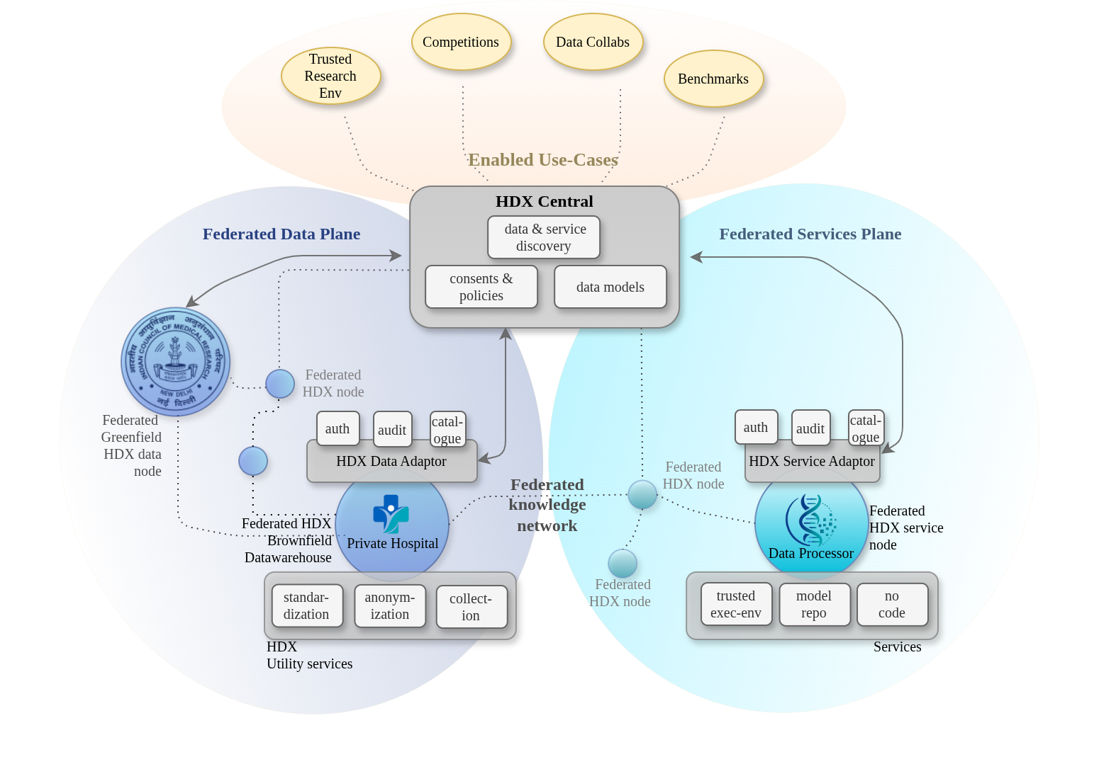
Figure 1: Federated Health Data Exchange

The Data Marketplace
The HDX exposes a data marketplace in which data providers can publish indexed datasets, describe their metadata, define access conditions, and register consent policies. Consumers — researchers, technologists, policymakers — can discover datasets, understand their coverage and quality, and request access through governed, auditable pathways.

Metadata and Cataloguing Standards
The HDX adopts DCAT as its core, RDF-based vocabulary for cataloguing datasets and their metadata across the exchange — providing a standards-compliant, machine-interpretable discovery layer that federates cleanly across HDX nodes and supports agentic access.
Beneath the catalogue layer, each track declares conformance to track-specific standards that describe its datasets in greater detail. For the clinical track, the HDX standardises on the FHIR family of resources:
- FHIR CapabilityStatement — published by each federated node to advertise the FHIR data and operations it can serve, enabling automated discovery of node capabilities across the network.
- FHIR ResearchStudy — to describe the study a dataset originates from: what a given clinical trial was investigating and what the dataset therefore contains.
- FHIR EvidenceVariable — to give further context on what was actually recorded (the variables, exposures, and outcomes captured). For e.g a study declare an EvidenceVariable capturing Adults with Type 2 Diabetes and HbA1c > 7. This become important for operationalizing Pragmatic Clinical Trials
- FHIR + SNOMED CT + value sets — to define data types and bind coded elements to standardised terminologies and curated value sets.
- FHIR mCxDE — as the domain-specific minimum common data model for oncology. (We extend this idea to other domains through additional "mCxde" minimal common “any” data elements for x domain, detailed later.)
- DICOM summaries — Mode, purpose, body part examined, etc embedded within the DCAT catalogue item for the dataset
Considering the nature of Genomics data and the strong guardrails behind its accessibility, we propose a data discovery model that is privacy preserving and which enables the discovery of datasets containing the relevant subset that a user is interested in.
- GA4GH Beacon — published by each federated genomics node to support privacy-preserving, federated "does this dataset contain variant X" discovery queries across repositories without moving the underlying data, mirroring the discovery role of the FHIR CapabilityStatement.
- FHIR Genomics (MolecularSequence and related resources) — used at the boundary to link a participant's genomic record back to their clinical record, enabling the cross-study, genotype–phenotype linkage the platform is designed to support.

Minimum Common Data Models for “any” data elements mCxDE
mCXDE (Minimum Common Data Elements) is a family of domain-specific interoperability standards governed by the Health Data Exchange (HDX). Inspired by the success of mCODE in oncology, mCXDE establishes a standardized set of minimum data elements, terminologies, exchange formats, quality requirements, and semantic definitions required for interoperable data sharing within a specific domain.
Unlike generic metadata frameworks, each mCXDE profile is purpose-built for a particular domain and developed in collaboration with domain experts, researchers, providers, regulators, and ecosystem participants. Every profile defines the minimum common dataset necessary to support data exchange, analytics, research, and application interoperability while preserving compatibility with existing international standards.
The table below illustrates the various Layers of an mCXDE specification for Oncology, which is already a standard that’s followed (mCODE). Table 2 extends the concept to Diabetes.
Layer | Purpose | Example (Oncology mCODE)
Domain Scope | What domain is covered | Oncology
Information Model | Core entities and relationships | Patient, Cancer Condition, Tumor, Treatment, Genomics
Interoperability Standard | Exchange mechanism | FHIR
Terminology Standards | Semantic consistency | SNOMED CT, NCIt, ICD-O, LOINC
Context Model | Research and clinical context | Encounter, ResearchStudy, Specimen
Thematic Groupings | Organize concepts | Diagnosis, Staging, Treatment, Outcomes
Value Sets | Allowed values | Cancer Stage, Biomarker Status
Profiles | Constrained resource definitions | Primary Cancer Condition Profile
Quality Rules | Conformance requirements | Mandatory fields, cardinality
Analytics Mapping | OMOP and analytics models | OMOP Oncology Extension
Governance | Versioning and stewardship | HL7 mCODE governance
Table 1: mCODE specification with its various layers

Component | Diabetes mCXDE
Interoperability Standard | FHIR
Terminologies | SNOMED CT, LOINC, RxNorm
Data Context | Patient, Encounter, Device
Thematic Groups | Diagnosis, Labs, Medications, Complications, CGM
Value Sets | Diabetes Type, Complication Type
File Formats | FHIR JSON, Open mHealth JSON, CSV
Analytics Mapping | OMOP
Research Context | ResearchStudy, EvidenceVariable
Quality Rules | HbA1c ranges, glucose validity
Table 2: Example of mCODE extension for Diabetes

The dataset standards will be the data equivalent to the metadata standards described previously. Adherence to the above Data Exchange formats will be necessary and all measure to enforce a common data model will be made through the tooling and governance ecosystems described later.
In summary, the figure below captures the landscape of data standardization that will be undertaken for the HDX.
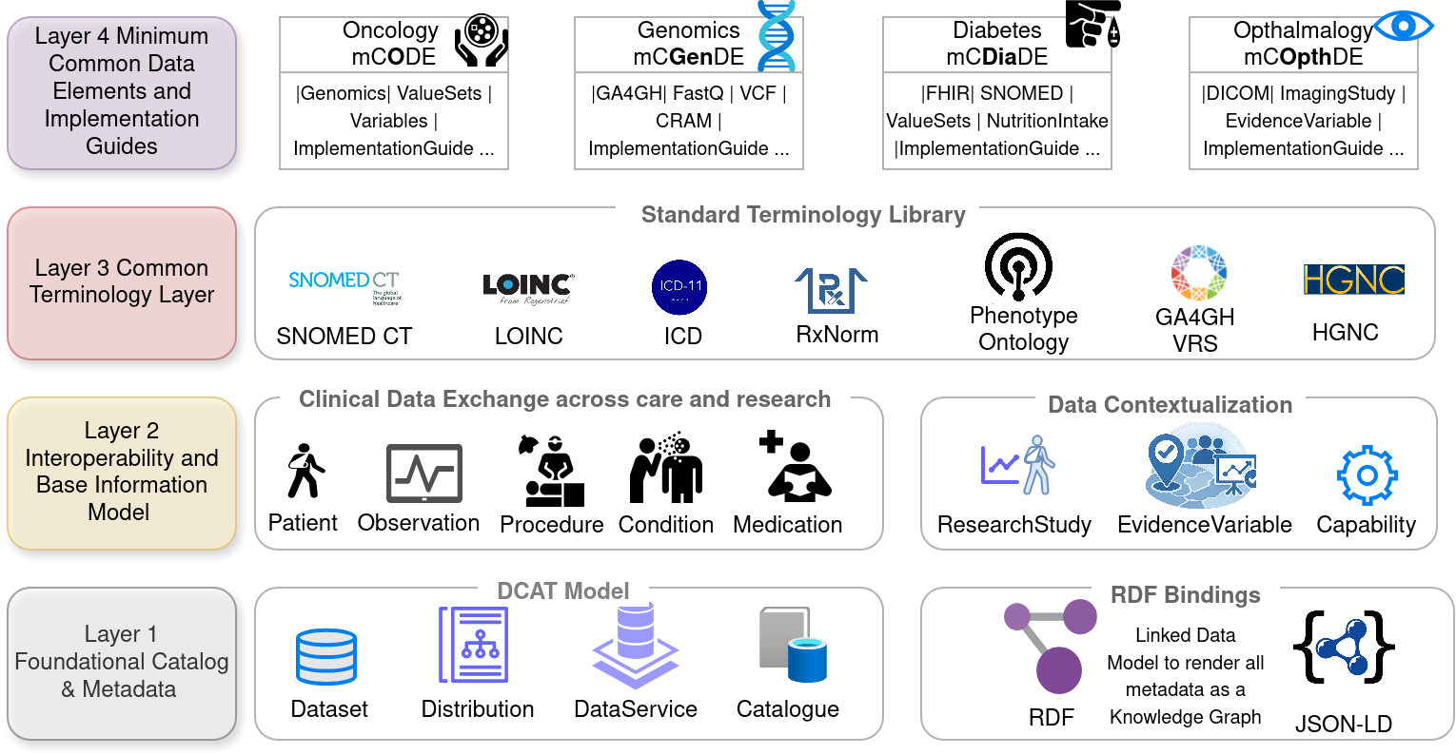
Figure 2: Landscape of data standardization

The Service Marketplace
The HDX is not solely a data marketplace. Data has little value to a researcher without the means to compute on it, yet the computational and data-engineering capabilities required for modern health research — large-scale model training, federated analytics, harmonisation, de-identification, statistical processing — are precisely the capabilities that individual research institutions most often lack. The HDX therefore implements a parallel service marketplace: an ecosystem of computational and data-processing services, natively integrated with the exchange, that consumers can discover and invoke. A consumer who has obtained data — through consent, a marketplace transaction, or any other governed access pathway — can "pipe" that data to a registered service for execution and receive provenance-tracked outputs in return. Service providers register their offerings alongside data providers, expose them through standardised interfaces, and may charge a fee, allowing a genuine economy of services to develop around the data on the platform.
The service marketplace supports, among others, the following classes of service.
Trusted Research Environments with TEE / Enclave Execution
The HDX supports the deployment of AI and analytical models against sensitive health datasets without either the model or the data leaving their respective secure perimeters. This addresses a fundamental trust dilemma: data providers cannot share datasets with modellers without risking exposure of their data, and modellers cannot share their models without risking their IP being copied. Trusted Execution Environments (TEEs) and secure enclaves resolve this — providing a hardware-enforced, cryptographically attested environment in which a model runs against data the operator cannot read, while the provider never sees the model. Both parties receive only the sanctioned outputs — predictions, statistical summaries, training gradients — without access to the other's IP; no party need trust any other. A data provider may therefore attach policies that make execution within such an attested environment a precondition of access — optional and at their discretion — and where required, the HDX may itself supply the computational resources to run these secure-compute environments, ensuring the capability is available to every provider on the network rather than only those with their own trusted infrastructure.
MLOps as a service
Standing up AI/MLOps infrastructure and executing large-scale model training is a substantial engineering undertaking in its own right — one that should not be added to the burden of doing the research. The service marketplace allows registered MLOps providers to offer model training, federated learning, and large-scale analytics as services on the exchange. By connecting data providers to these service providers at the behest of a single consumer action, the platform abstracts the complexity away: the researcher specifies what they want done, and the HDX orchestrates the data access, the computation, and the return of provenance-tracked results across the relevant parties — without the researcher having to provision or operate the underlying compute themselves.

Federated Query Aggregation as a service
The service-marketplace abstraction is general enough that core platform functions can themselves be modelled as services within it. Federated query aggregation — dispatching a query across multiple federated nodes and aggregating their responses into a single result — is naturally expressed as a service on this ecosystem, consumed in exactly the same way as any third-party offering. Modelling it this way unifies the platform's own federated-analytics capability with the broader service economy under a single, consistent architectural model, and means the same governance, consent, and attestation guarantees that apply to external services apply equally to the platform's native query layer.

Federated Learning and DEPA
Federated learning (enabled through a platform service and potentially TEE environments mentioned above) is a foundational capability of HDX, enabling AI and analytical models to be trained across datasets held by multiple institutions without requiring the underlying data to leave its source. This approach is essential for addressing population-scale research questions that span diverse clinical, genomic, imaging, and public health datasets distributed across India's healthcare ecosystem.
To support trusted cross-institutional analytics, HDX builds upon India's Data Empowerment and Protection Architecture (DEPA). DEPA provides the consent, governance, and purpose-limitation framework necessary for responsible data use. HDX extends these principles to federated computation through purpose-bound analytics, delegated consent management, auditable execution workflows, and end-to-end provenance tracking. Together, federated learning and DEPA enable secure, privacy-preserving, and consent-aware research at national scale while ensuring that data remains under the control of participating institutions.

The Data provider Tooling Ecosystem
A federated data exchange is only as valuable as the data that flows into it. The central challenge for HDX adoption is provider onboarding. Most health data in India exists in formats that are not analytics-ready: unstructured clinical notes, proprietary EHR exports, inconsistent terminologies, incompatible schemas. A data provider cannot register on the HDX without first transforming their data into a format that is discoverable, standardised, and usable.
Even for standardized datasets, there is a domain understanding that is native to the data providers native ecosystem, and the data may not have all the variables according to the domain verticals minimum common data elements.
When we open up the Data Exchange ecosystem to larger participation, it is also important to contextualize the data using Metadata and Data Standards mentioned in the previous section (for e.g FHIR EvidenceVariables)
A large part of HDX's activities will therefore centre on a tooling ecosystem designed to reduce the cost of provider onboarding to near zero. This ecosystem has several components:

Field / Source Data collection utilities
The cost of onboarding to the HDX is lowest when data is captured in a standards-conformant form at the moment of collection, rather than reconstructed from messy exports after the fact. The HDX therefore provides a data collection toolkit — an end-device application paired with a backend ingestion and harmonisation system — that standardises and streamlines capture directly at source. The application is designed for frontline use by ASHA workers, ANMs, field surveyors, and clinic staff, and the backend maps each captured record onto the appropriate track standard (FHIR resources, the relevant mCxDE profile, coded to SNOMED CT / LOINC / ICD) so that data lands on the exchange already conformant and analytics-ready.
This is particularly valuable for epidemiological and population-health data collection, where the scientific value of a dataset depends on consistent, comparable capture across thousands of dispersed field workers and sites. By enforcing the common data model and controlled vocabularies in the collection instrument itself — structured forms, validated value sets, mandatory minimum data elements — the toolkit removes the downstream burden on data providers of curating, recoding, and reformatting their data into a shareable form, shifting that effort from a costly post-hoc cleanup to a one-time configuration at design time.
To make standardised capture viable in real field conditions across India's linguistic diversity, the application supports vernacular language and speech-based data entry: forms, prompts, and value-set labels are rendered in regional languages, and field workers can record observations by voice in their local language, with on-device or backend speech-to-text and semantic mapping resolving the spoken input back to the underlying coded data elements. This lowers the literacy and training barrier to accurate capture while preserving full conformance to the exchange's data standards.

Agentic Data Conversion and Transformation Utilities
AI-driven, agentic pipelines that accept raw institutional data exports — in any format, at any quality level — and produce schema-compliant, analytics-ready datasets. These pipelines are not one-size-fits-all: they are trained on Indian clinical data characteristics, capable of resolving India-specific terminology and regional language medical records, and designed to learn from prior harmonisation cases. They operate iteratively, with human-in-the-loop review for cases where automated resolution is uncertain.
The agentic layer handles schema mapping (aligning variable names and data structures across institutions), semantic concept mapping (resolving synonyms, abbreviations, and local terminology to SNOMED CT, LOINC, RxNorm, and ICD standards), and format conversion (transforming proprietary EHR exports into FHIR-compliant structures or OMOP common data model representations).

Anonymisation and De-identification Utilities
Health data cannot be shared on the HDX without first being de-identified to regulatory standards. Anonymisation of structured data is well-understood; de-identification of unstructured clinical text — discharge summaries, radiology reports, clinical notes — requires AI models trained specifically on Indian clinical language. The HDX tooling ecosystem includes purpose-built de-identification pipelines that detect and redact protected health information embedded in free text, with mandatory verification that all PHI has been removed before a dataset is published to the exchange.

The anonymisation layer also implements differential privacy, k-anonymity, and data generalisation techniques appropriate to each dataset type and the sensitivity of the variables it contains. Providers receive a de-identification report with each processed dataset, documenting the techniques applied and the residual privacy risk assessment.

Integrating Brownfield Deployments
Much of India's most valuable health data already lives inside established systems — hospital EHRs, laboratory information management systems, research-lab data warehouses, and institutional registries — each with its own schema, storage technology, and access conventions. These brownfield deployments cannot be expected to rip out and replace working infrastructure as a precondition of joining the network, nor should the burden of writing bespoke integration code fall on every participating institution. The HDX therefore treats brownfield onboarding as a first-class problem and provides an agentic integration approach that connects existing systems to the exchange with minimal effort from the data provider.
Rather than requiring a provider to manually re-engineer their data pipeline, the platform deploys agents that inspect the source system — its schema, table structures, terminologies in use, and access interfaces — and automatically generate the adaptors and proxies needed to bridge it to the HDX. These adaptors handle the translation work that would otherwise be done by hand: mapping the source's native schema onto the appropriate track standard (FHIR resources, the relevant mCxDE profile), binding local codes to the common terminologies (SNOMED CT, LOINC, ICD), and exposing the data through the exchange's standardised, API-first interfaces. The proxy sits at the institutional boundary so that data continues to reside within the provider's fiduciary control, with the adaptor presenting a conformant, federated-query-able view to the network rather than copying data out of the source warehouse.
The result is that a hospital EHR or a research lab's data warehouse can be brought onto the HDX as a federated node without disrupting its internal operations and without a large bespoke engineering project. The agentic layer reduces the marginal cost of integrating each new brownfield system toward zero, which is what makes participation feasible at national scale — every additional institution that joins reuses the same agentic tooling rather than commissioning a one-off connector.

03 Use cases enabled by the HDX

1. Trusted Research Environments (TREs)
HDX enables secure Trusted Research Environments powered by Trusted Execution Environments (TEEs) and confidential computing technologies. Researchers can execute approved analytical workloads on sensitive datasets without direct access to the underlying data, ensuring privacy, regulatory compliance, and institutional trust. This capability supports clinical research, population health studies, AI model development, and regulated data access scenarios.

2. Research Competitions and Hackathons
HDX provides a native platform for organizing data science challenges, benchmarking exercises, and innovation competitions on sensitive healthcare datasets. Participants can develop and evaluate models through secure compute environments without accessing raw data, enabling broader participation from academia, startups, industry, and researchers while preserving patient privacy and institutional control.

3. Data Collaboratives and Federated Registries
HDX enables multiple institutions to participate in collaborative research initiatives, disease registries, and longitudinal studies without centralizing data. Participating organizations retain ownership and control of their datasets while contributing to shared analytics, cohort studies, and evidence generation. This reduces concerns around data sovereignty, competitive disadvantage, and loss of institutional value while enabling large-scale collaboration.

4. Knowledge Graphs and Data Commons
HDX supports the creation of large-scale health knowledge graphs and data commons that connect datasets, studies, cohorts, publications, terminologies, and analytical assets through a common semantic framework. These capabilities enable researchers, clinicians, and AI agents to discover, navigate, and reason across diverse health datasets, facilitating explainable, cross-domain exploration and analysis.

5. Benchmarking and Evaluation Ecosystems
HDX enables trusted benchmarking of algorithms, models, and analytical methods against sensitive reference datasets. Organizations can publish benchmark tasks and evaluation protocols while keeping underlying datasets protected. This allows the creation of transparent leaderboards, reproducible evaluation frameworks, and domain-specific performance benchmarks that accelerate innovation and solution quality across the healthcare ecosystem.

6. Foundation Model Development and Large-Scale AI Training
HDX provides the infrastructure required for training AI models across distributed clinical, imaging, genomic, and public health datasets at national scale. Through federated learning, privacy-preserving computation, and governed data access, HDX enables the development of domain-specific foundation models, multimodal AI systems, and next-generation healthcare intelligence while ensuring compliance with consent, governance, and privacy requirements.

04 WHY EXISTING FRAMEWORKS ARE INSUFFICIENT

Several international federated data platforms have established themselves as reference architectures for health research data infrastructure. The most widely deployed include i2b2/SHRINE, PCORnet, OMOP/OHDSI, DataSHIELD, OpenSAFELY, and the N3C. Each represents a genuine advance over siloed institutional data management. None is sufficient for the use cases and scale of India's ambitions.

Capability | i2b2 / PCORnet | OMOP / OHDSI | OpenSAFELY | N3C | DataSHIELD | HDX
Federated Architecture | ✅ | ⚠️ | ⚠️ | ⚠️ | ✅ | ✅
Cohort Discovery | ✅ | ✅ | ⚠️ | ✅ | ⚠️ | ✅
Common Data Model | ⚠️ | ✅ | ⚠️ | ✅ | ❌ | ✅
FHIR-native Exchange | ❌ | ⚠️ | ⚠️ | ⚠️ | ❌ | ✅
Imaging (DICOM) | ❌ | ⚠️ | ⚠️ | ⚠️ | ❌ | ✅
Genomics (GA4GH) | ❌ | ⚠️ | ⚠️ | ⚠️ | ❌ | ✅
Multi-modal Data (Clinical + Imaging + Genomics) | ❌ | ⚠️ | ⚠️ | ⚠️ | ❌ | ✅
Consent & Policy Enforcement | ⚠️ | ❌ | ⚠️ | ⚠️ | ⚠️ | ✅
Privacy-preserving Analytics | ❌ | ❌ | ✅ | ⚠️ | ✅ | ✅
TEE / Secure Enclave Compute | ❌ | ❌ | ⚠️ | ❌ | ❌ | ✅
AI / ML Workbench | ❌ | ⚠️ | ⚠️ | ⚠️ | ❌ | ✅
Metadata Catalog (DCAT/RDF) | ❌ | ❌ | ❌ | ❌ | ❌ | ✅
Multi-domain Federation | ❌ | ❌ | ❌ | ❌ | ❌ | ✅

Centre of Data for Public Good (CDPG) · Indian Institute of Science, Bengaluru · June 2026
dataforpublicgood.org.in · info@cdpg.org.in

